Evaluation for task 2

Task 2 is basically the user entering a sentence which is then turned into a list. From there, the words are taken from the list and stored in a file, as well as the words positions being stored in another file.

My task 2 does exactly this, it can take any sentence or paragraph and split it up into words which are then stored in two separate files of words and positions. This also includes and punctuation and capitalisation.

In terms of difficulty, I found task 2 easier than task 1 as I could take my string formatting and while loop knowledge from task 1 over to task 2. Then all I needed to do was use For loops after opening or creating files to write to. This was easily done with a little research online.

Let’s take a look at the criteria list from the task analysis for task 2.

* Sentence input
* Sentence into list
* List written to file
* For loops for lists
* 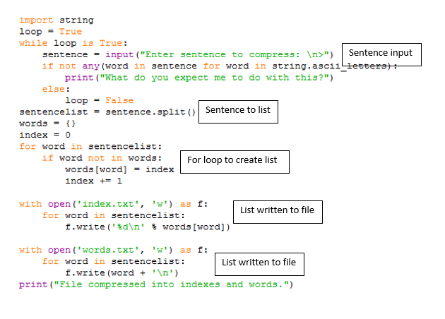Keep capitalisation and punctuation